

Functional Specification Documentation
Approval User Interface

PricewaterhouseCoopers GHRS

Version No.: 4.0
Date: 11-October -16

Table of Content
1.Approval user interface 2
1.1 Requirements 2
1.2 functions 2
1.3 approval window 3
1.4 details 5

Approval User Interface

  - Requirements

- To display in one screen PR/PO documents from all entities pending for approval
- Give access to approver to view details of PR/PO and make decisions to;
  - Approved
  - Not Approved
  - Pending
- Options to approve in batch or per document

  - Functions
- Program will display all documents pending for approval base on selection parameters;
  - Approvers
  - Document Type
  - Draft No.
  - Vendor code/Name
  - Creator/Originator
  - Document Date
  - Entity
- When document is approved refresh the screen and removed from display
- Program can run in all the entities
- Option to open and view PR/PO documents for running entity (current database)
- Option to view PR/PO details relating to other entities
- Options to approve all PR/PO from all entities
- Allow sorting of data per column ( Ascending/Descending order)

  - Approval Window

- To launch approval window program

  - Go to Customization – Approval

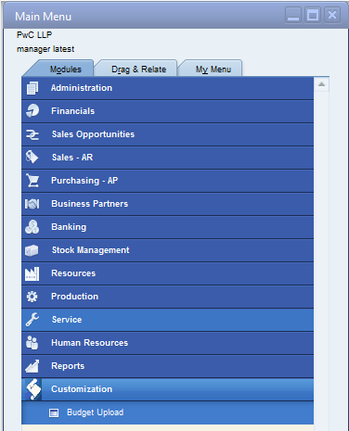
Approval Window

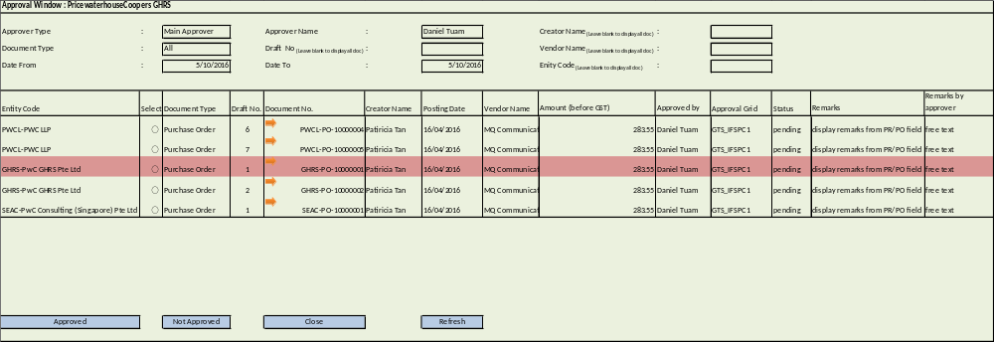

  - Details

    - Header Details
- Approver Type
  - Drop down selection list ( from @AB_APPROVALMATRIX)
    - Main Approver
    - Alternate approver
- Approver Name
  - Default to current user name based on login ID and display pending PR/PO for his approval
- Creator Name
  - By default is set to blank to display all data
  - Option to display selection list of creator name for PR/PO document. If creator is selected then display documents as per selected creator only
- Document Type
  - By default is set to ‘All’ to display all data
  - Drop down selection list
    - PR - Purchase Request
    - PO - Purchase Order
    - All
- Draft No.
  - By default is set to blank to display all data
  - Option to display all draft key number base on documents selected
  - If draft key is entered or selected display relevant data as per the selected draft key only
- Vendor Name
  - By default is set to blank to display all data
  - Option to display list of vendor base on document selected
  - If vendor is entered or selected display relevant data as per the selected vendor only
- Date From/Date To
  - Date From
    - is editable and set to blank by default ( to display all pending PR/PO)
    - if date from is entered, display data as of the date selected
  - Date To
    - By default display the current system date in “Date To” field (to display all pending PR/PO as of current system date)
    - If date is altered then display data as of the date selected
- Entity Code
  - By default is set to blank to display all data
  - Option to display list of entities on document selected (drop down selection)
  - Selection list should display entity name and code
  - If entity is entered display relevant data as per the selected entity only

    - Contents/ Line details
- Entity Code - display entity code and name for the owner of PR / PO document (source database)
- Select
  - option to check all or check per document
  - checked or selected document will be subject for decision
- Draft No. – display unique key for each PR/PO document pending for approval
- Document No.
  - Temporary document number assigned to PR/PO pending for approval
  - PR/PO may have the same document number but different draft number
  - Orange Arrow ( ) – click to view PR/PO document details
    - If PR/PO owner is the entity where program is running , program will display SAP PR/PO screen
    - If PR/PO owner is not the entity where program is running, program will display details of PR/PO selected ( refer to item 1.4.4 for the screen display of relevant information)
- Creator Name – display the name of PR/PO creator
- Posting Date – display the date of PR/PO
- Vendor Name
  - display the supplier name where goods/services are purchased
  - If document is PR vendor field is blank
- Amount (before GST) – display total amount before GST
- Approved by– display name of the last approver, If user is the first approver display remarks as “you are the first approver”
- Approver Grid – display code for approval template
- Status – PR/PO approval status. By default is display pending and after decision it should display approved or not approved
- Remarks from creator– display the remarks entered in PR/PO remarks field
- Remarks by approver – free text to enter reason for not approving the document

    - Footer Details
- Approved - click to approved checked/selected documents
- Not Approved - click to reject checked/selected documents. Enter reason for not approving in remarks by approver field
- Close – click to exit and close approval screen window
- Refresh – click to refresh the display of data. The approved document will be removed from the display

    - Display screen for other entities PR/PO details

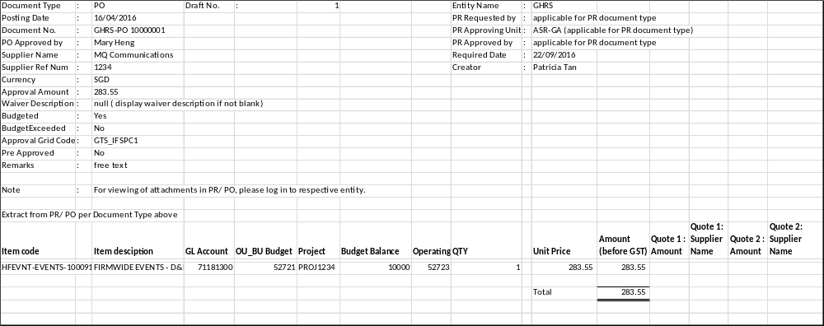

SAP Mapping
Document Type | : | PR or PO
Posting Date | : | DocDate
Supplier Name | : | OCRD.CardName
Supplier Ref Num | : | NumAtCard
Currency | : | DocCur
Waiver Description | : | U_AB_WAIVER (if blank display null)
Approval Amount | : | U_AB_APPROVALAMT
Budgeted | : | U_AB_BudgetedCost (Yes/No)
BudgetExceeded | : | U_AB_BudgetExceeded (Yes/No)
Approval Grid Code | : | U_AB_APPROVALCODE
Pre Approved | : | U_AB_PREAPPROVED(Yes/No)
Remarks | : | Comments
Notes | : | For viewing attachment please login to entity(hardcoded)
Entity Name | : | Source Db Name
Document No. | : | DocSeriesName+DocNum
Requester Name | : | OPRQ.ReqName
Approving Unit | : | U_AB_PURCHSEDEPT
PR Approved by | : | display the names of PR approver
Required Date | : | OPRQ.Reqdate
Creator | : | UserSignature
PO Approved by | : | display the names of PO who already approved

